
Installation Instructions
Kolbus 472 & 491 Binder
with a fixed 6mm hinge
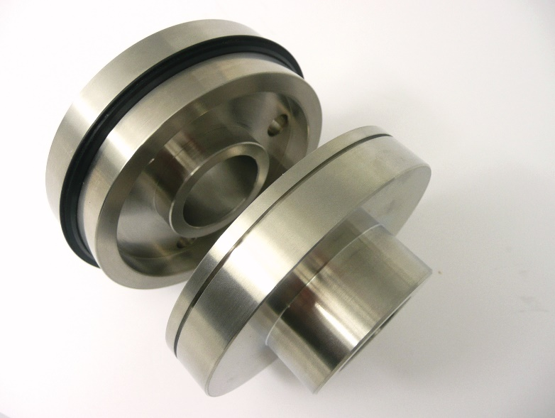
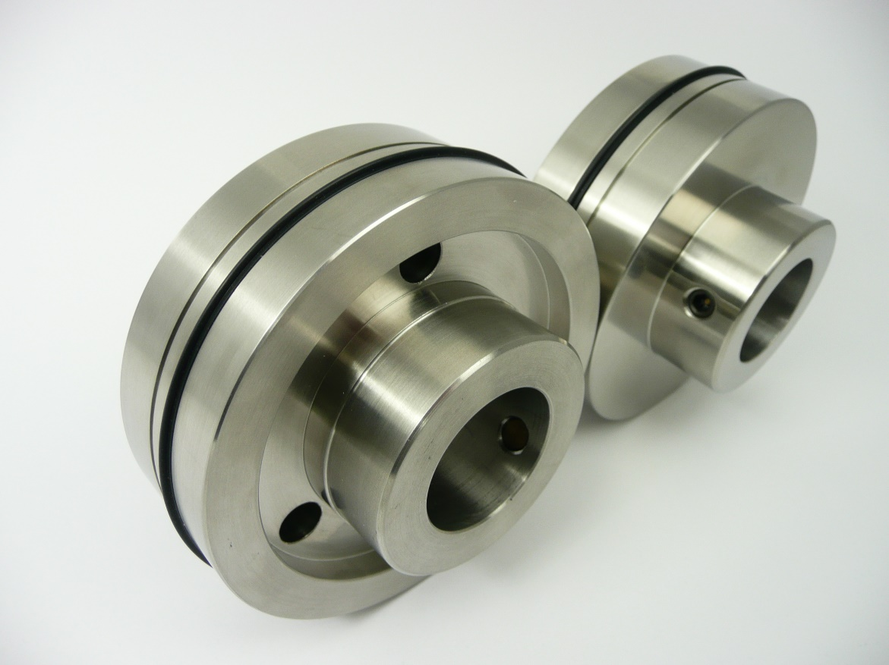
To fit a Kolbus Binder with a 30mm shaft &
114mm Roller Outer Diameter

All 4 creasing units are identical.
Slide the parts apart to remove and change the creasing ribs.

Rubber & Plastic Creasing Ribs
The Rubber Creasing Rib will crease cover stocks up to 350gsm and should be used when the elimination of fibre-cracking is required.
The Blue dot inside the black Nylon Creasing Rib indicates a medium crease profile used on lighter paper laminated covers or cover stocks not prone to fibre-cracking.
Nylon Ribs that have no blue dot are a heavier crease profile also suitable for laminated covers or stocks not prone to fibre-cracking.
Once the crease units are on the shaft, insert the split nylon ribs into the units. This will avoid any damage to the crease profiles.

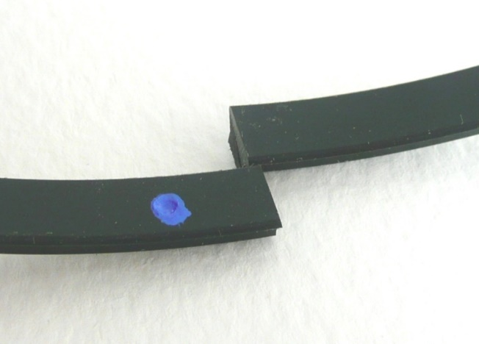

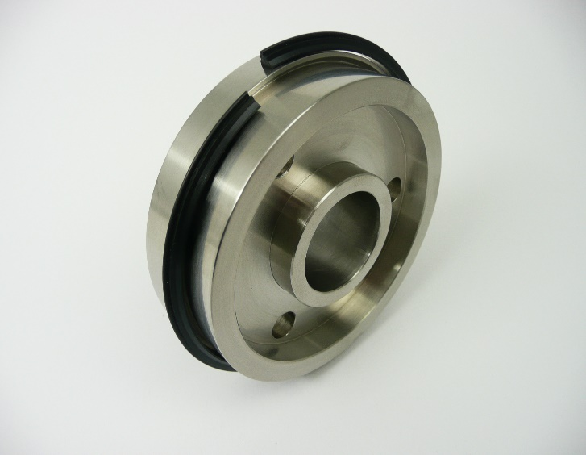

Removal of the split creasing rib.
To stop rib damage please remove ribs from the crease units before installation onto the shafts.

Gripper Boss Support Rollers

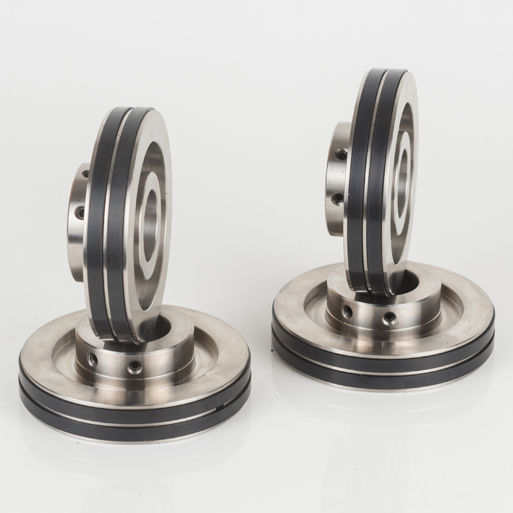
113.5mm
114mm
The TOP Support Rollers have 2 Gripper Bands built into each collar.
Each of the black rubber grippers has a different amount of grip.
The outer diameter grip sizes are 113.5mm & 114mm.
To achieve perfect grip each gripper can be used individually.
The bottom support collars are a solid metal construction.

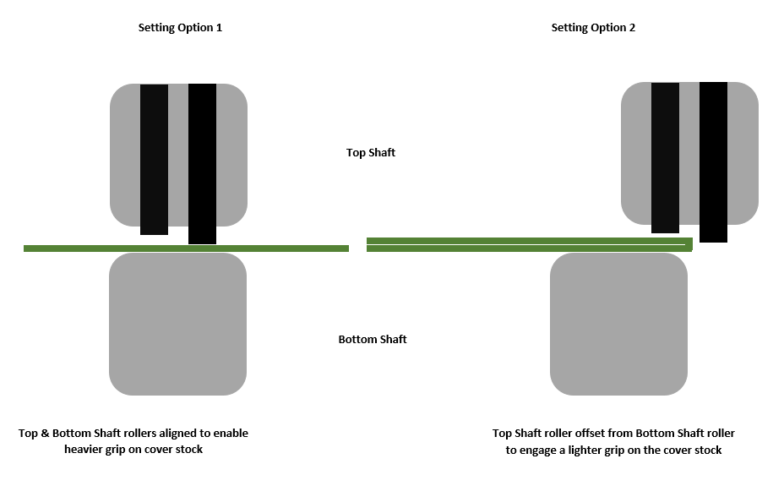
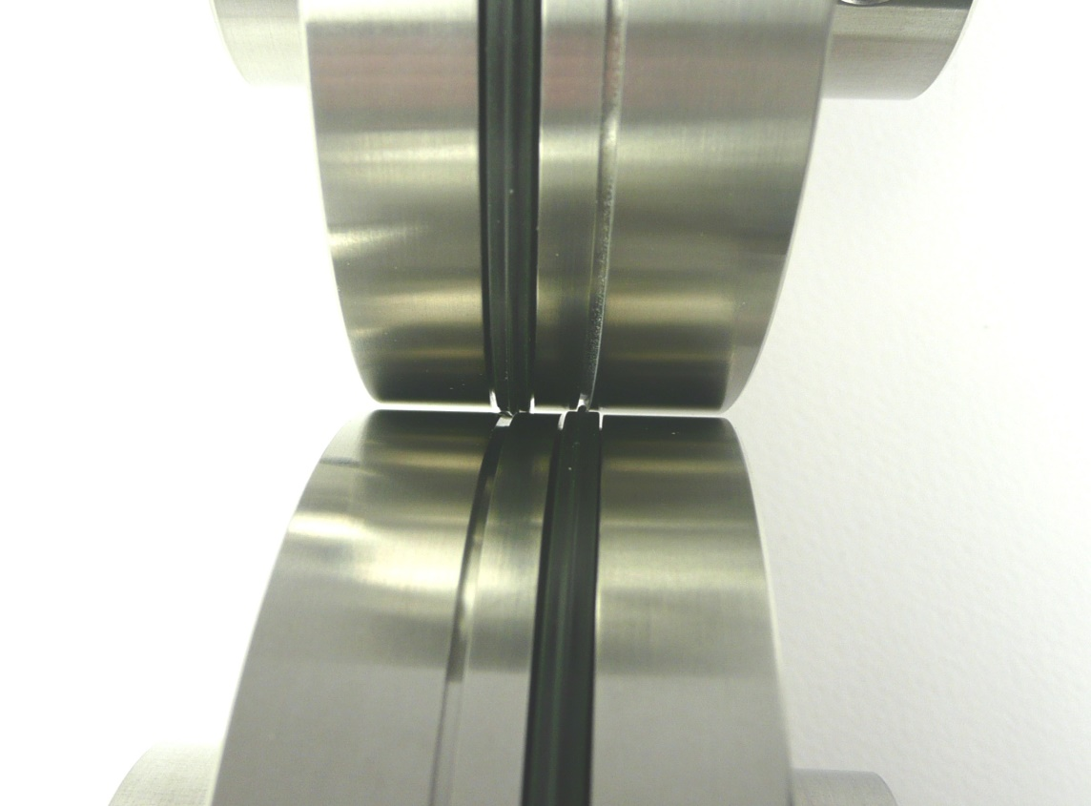
Installing The Bottom Shaft Parts
Attach the chosen split rubber or nylon crease ribs that correspond to the thickness of cover stock you are needing to process.
Align a bottom crease unit with the edge of the book clamp and tighten fixing screws.
Align the remaining bottom crease unit into the desired position and tighten the fixing screw.
Installing The Top Shaft Parts
It is important to use the Tech-ni-Fold Top Gripper Boss Support Rollers and plain metal Bottom Support Rollers.
To achieve the correct grip between the support collars, align the collars and slowly lower the top shaft until gentle grip pressure is obtained.
As the shaft is being lowered slide the top crease units so that the protrusion on the crease rib falls into the bottom female channels.
Leave the fixing screws on the Top Shaft Creasing Components untightened.
Jog a sheet of 300gsm cover stock between the crease units.
As the cover stock feeds through the rotating shafts the Top Shaft Creasing Protrusions automatically adjust to the optimal central crease position in the receiving female channels.
With the cover stock still in-between the creasing components, carefully tighten down the fixing screws in the Top Shaft Creasing Components when they come into view.
To achieve the optimum crease the creasing ribs must locate in the centre of the channels.

